**Ronisha Hill - Data Analysis Portfolio**

**About**

Hello, I'm Ronisha, a health informatics professional with 5+ years of experience analyzing patient data in various healthcare roles and settings. I enjoy transforming raw data into meaningful and actionable insights used to make data-driven decisions, improve patient outcomes, and assist in optimal healthcare management. Through analytical and big picture thinking, I excel at uncovering patterns and trends within complex datasets, which can be used to guide strategic business decisions and meet organizational goals.

I am dedicated to lifelong learning and keeping up with the latest developments in healthcare and data analytics. Alongside holding a Bachelor's and Master’s degree in Statistics, I have strong proficiency in tools such as SQL, R, Excel, Tableau, Power BI, and others.

**Table of Contents**

* [Portfolio Projects](https://github.com/ronishahill/Data-Analysis-Portfolio/blob/main/README.md#portfolio-projects)
  + Tableu
* Tableu 1: Story : <https://public.tableau.com/app/profile/md.ashraful.haque/viz/Super_Sales_17461404503900/Improveprofitsinthesouth>
* Tableu 2 : Dashboard : <https://public.tableau.com/app/profile/md.ashraful.haque/viz/Super_SalesDash16_5_25/Dashboard1>
* Tableu Assignment Dash 1: <https://public.tableau.com/app/profile/md.ashraful.haque/viz/MigratedData1/Dashboard1>
* Tableu Assignment Dash 2: <https://public.tableau.com/app/profile/md.ashraful.haque/viz/MigratedData_17476788962500/Dashboard2>
  + Power BI
    - Power BI 1: <https://app.powerbi.com/groups/me/reports/f68b1c1c-86c6-432c-960a-b558feaa7940/ca7e68e3ee55a96dd2ad?experience=power-bi>
    - Power BI 2: <https://app.powerbi.com/groups/me/reports/cab9e806-317b-479c-b8ad-0adbdb866eed/8f11d1e970ed6e798305?experience=power-bi>
* [Contact](https://github.com/ronishahill/Data-Analysis-Portfolio/blob/main/README.md#contact)

**Portfolio Projects**

This section contains a list of completed projects as well as a brief description of each project:

**Super Store Project**

**Dashboard:**

The data is of 22 types of products (chocolates) distributed in 6 countries sold by 25 sales persons. Total number of boxes shipped is 166K and the amount is 6Million.

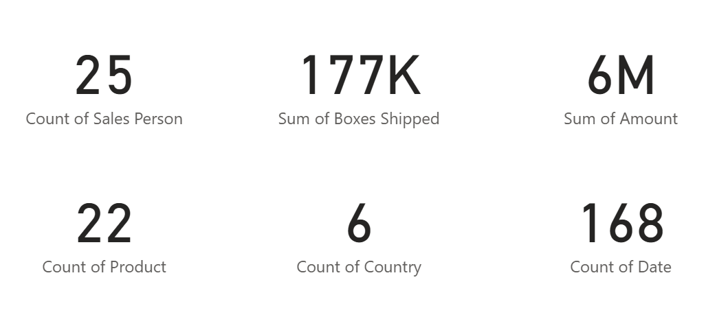

The highest number of boxes shipped in Australia, Canada and UK respectively but the amount of Canada is pretty much low than others.

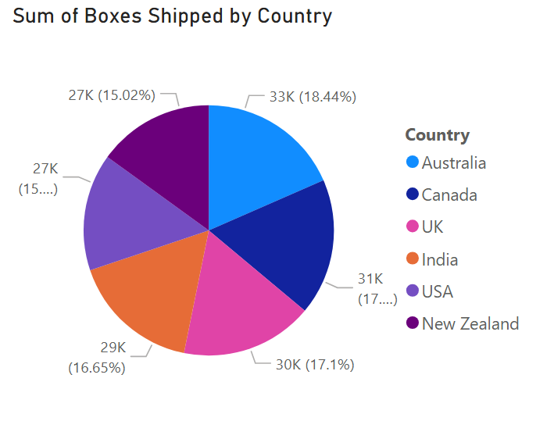

The highest number of boxes shipped in Australia, Canada and UK respectively but the amount of Canada is pretty much low than others.

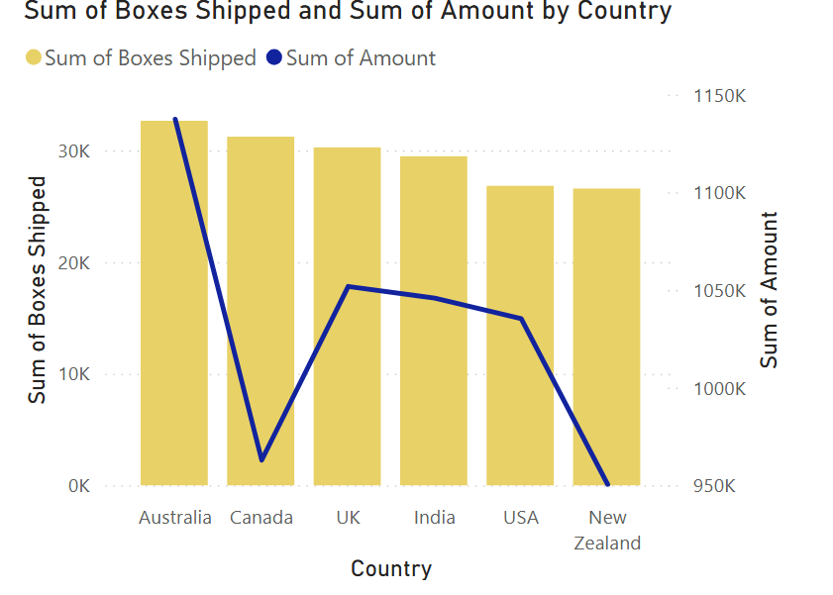

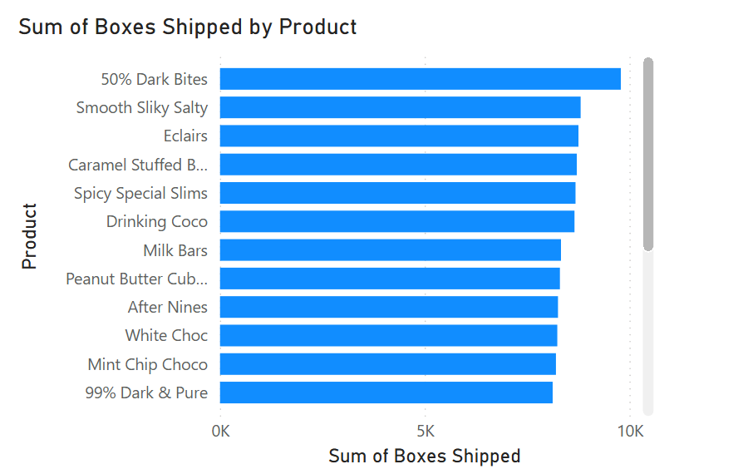

Above graph shows that highest products shipped is “50% Dark Bites”, “Smooth Silky Salty” and “Eclairs”.

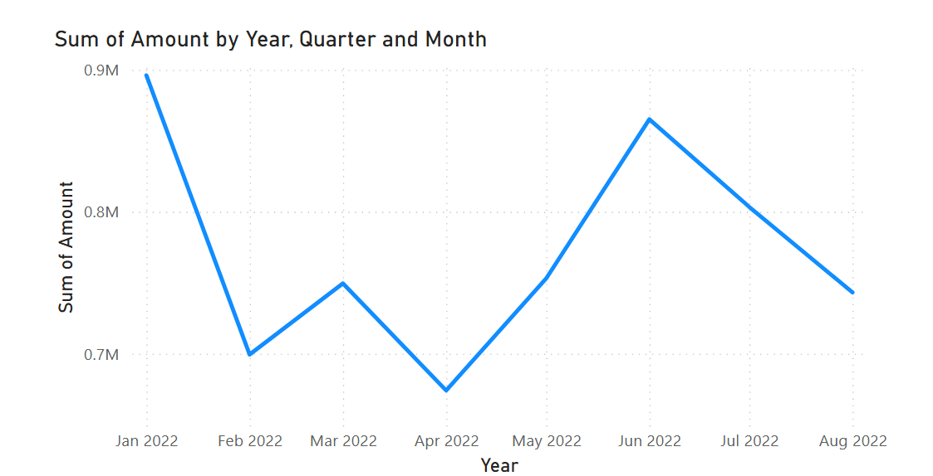

In the above graph showed that, there was 21.95% decrease in amount from Jan’22 to Feb’22 and there was 10.06% decrease in amount from Mar’22 to Apr’22.

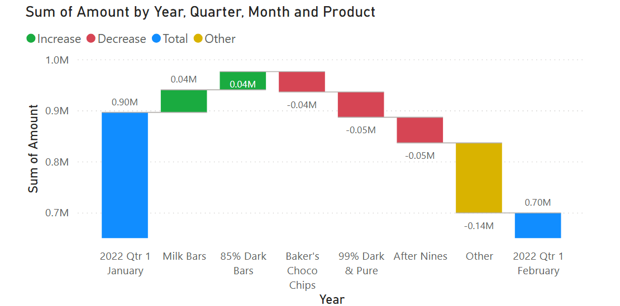

The graph shows that in 21.95% decrease time Milk Bars and 85% Dark Bars amount was increased; but the main three culprit was “Baker’s Choco Chips”, “99% Dark & pure” and “After Nines” for which the amount was decreased.

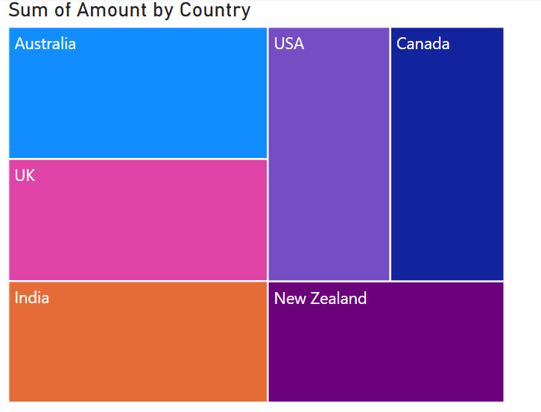

The three graph shows the amount of Australia was the highest in this period of time.

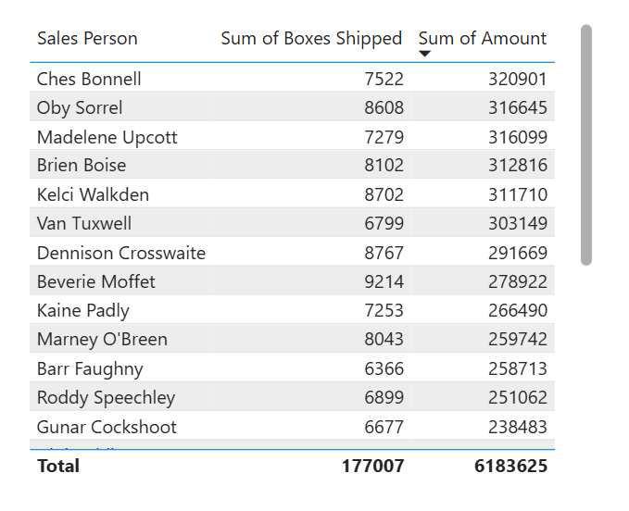

The table shows that Sales person Beverie Moffet shipped the maximum boxes (7522) but Ches Bonnell got the most amount (320901).

Power BI 2:

In 48 states of 5 regions; 3739 retailers sold 4 million units of 6 beverage brand and achieved revenue was 2 million.

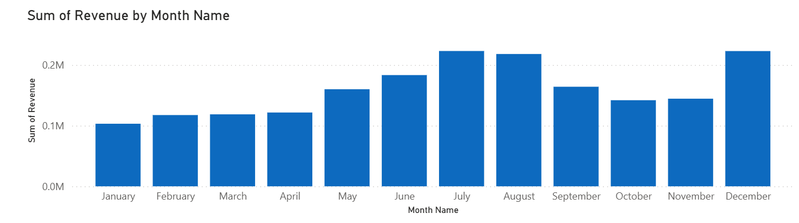

The graph shows that in the month of July, August and December had the highest revenue. It was presumed that in July and August was the Summer but December’s peak describes the occasion season.

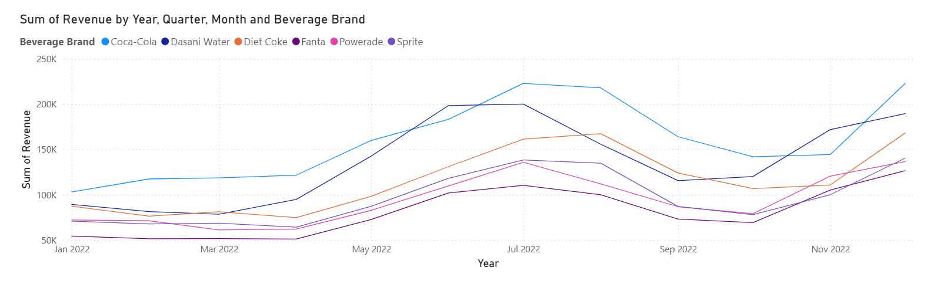

The graph shows that, Cola-cola Brand was famous in holiday seasons. Cola-cola hold 23.4%, Dasani Water holds 19.99%, Diet Coke holds 16.93% and Sprite holds 14.1% in these periods of time.

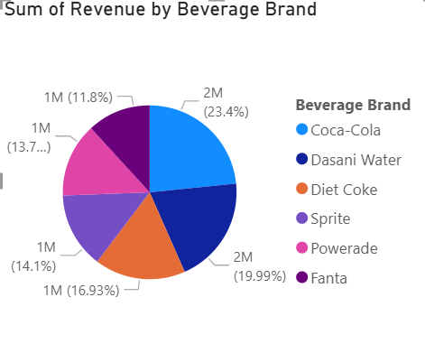

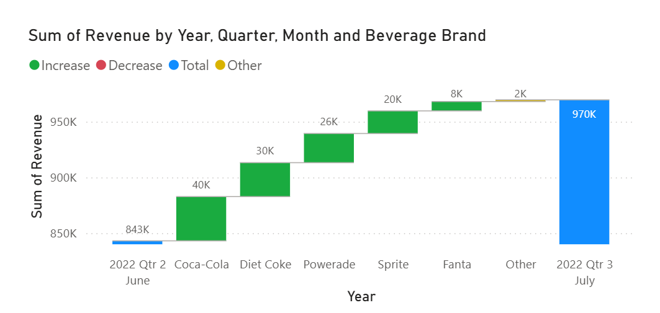

The revenue was increase by 15.01% from June 2022 to July 2022. In these period Coca-Cola, Diet Coke and Powerade has the most peaks.

**Tableau Project:**

The data given for assignment contains 22 variables about shipping date of office equipment’s and furniture of USA. The summary is given below:

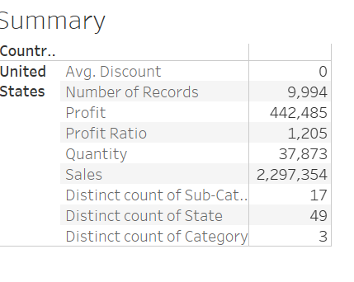

Now, if we focus on the highest profitable state, extracting from the map we got California as the highest profitable state with maximum discount.

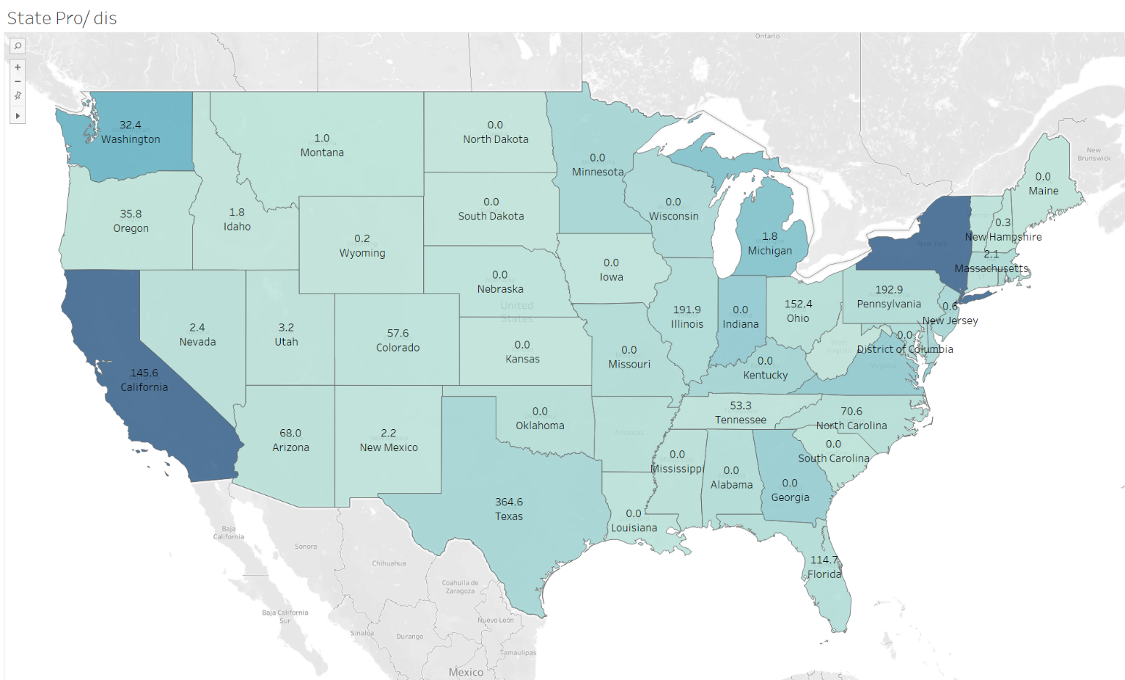

Region wise the sales was highest in West and the profit was highest in East. South region has the lowest profit.

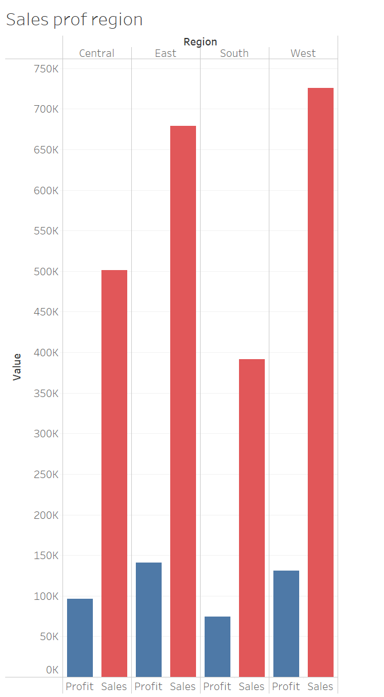

The time series chart shows that Profit and sales both falls in Q1 of every seasons and had the high peak in Q4 of every season.

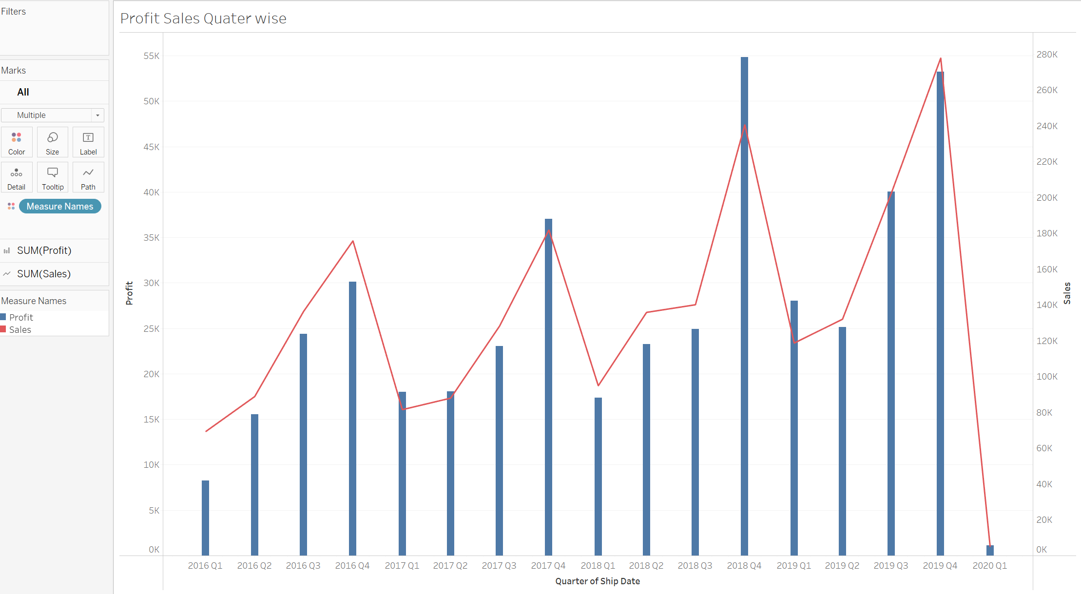

The first dashboard looks like this;

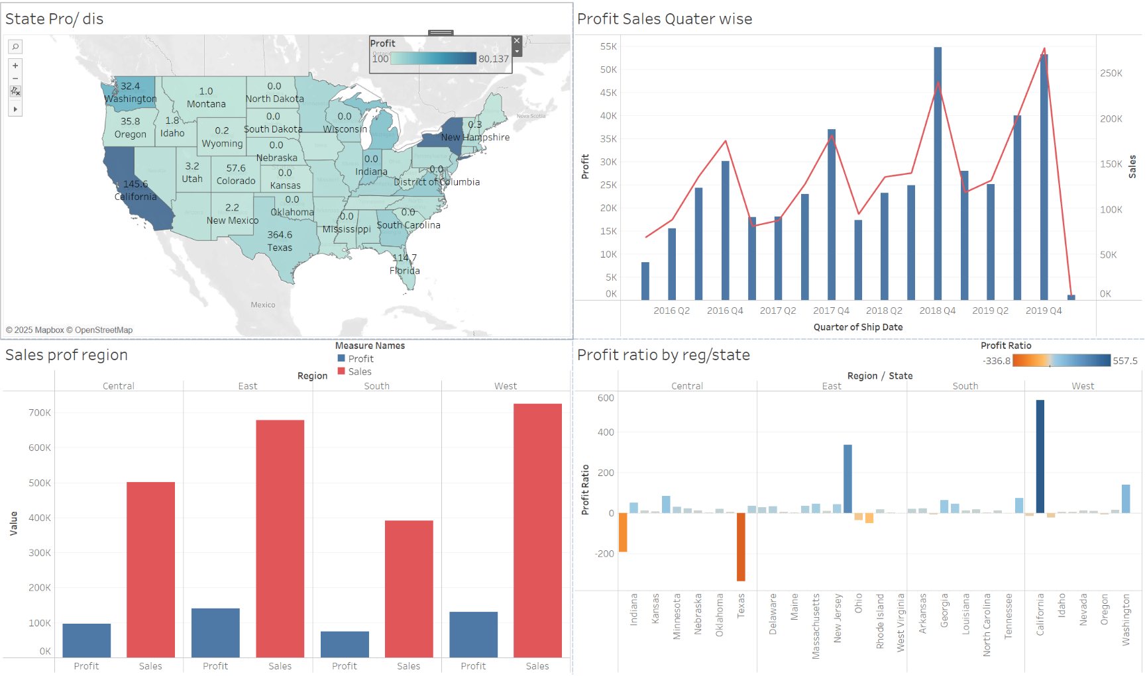

Profit ratio (Profit/sales) of region and state shows that Texas and Illinois State had negative ratio.

To find more about that; the next dashboard shows;

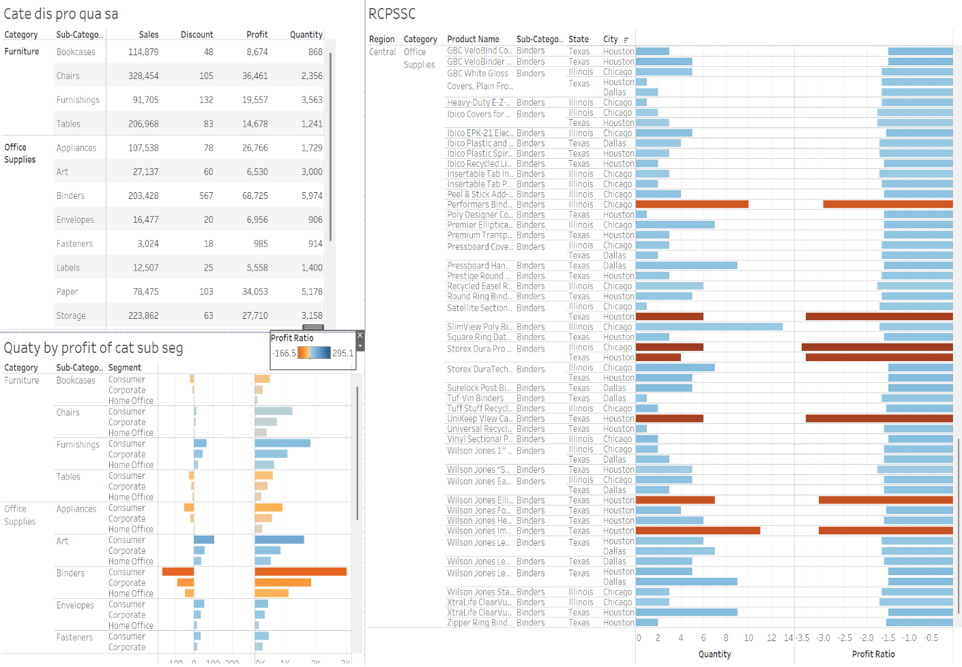

From the above dashboard; it shows that office supplies “Blinders” has the least profit ratio and maximum amount of quantity.

Also, in Texas and Illinois State; Houston, Chicago and Dallas cities had least profit ratio.

We can see that Blinders had the highest discount rate.

**Technology:** R, Python, SPSS, SQL, Power BI, Tableau, Advance Excel

**Education**

* Shahjalal University of Science & Technology, MSc, BSc in Statistics

**Contact**

* Linkedin: <https://www.linkedin.com/in/ashraful-haque-555352263>
* Email: [mdashraful.nrcc@gmail.com](mailto:mdashraful.nrcc@gmail.com)